Excel Assignment – 18

1. What are comments and what is the importance if commenting in any

code?

Ans-

In Microsoft Excel, comments are notes that can be added to cells to provide additional information about the data or calculations in the cell. You can see the comments by hovering over the cell or by selecting the cell and viewing the comments from the "Inspect" tab of the Excel ribbon.

The importance of commenting in Excel code lies in its ability to improve the understandability and maintainability of a spreadsheet. Here are some reasons why commenting is important:

-Explanation. Comments can explain the purpose of a calculation or the data in a cell, making it easier for others to understand the purpose behind the formula.

-Documentation: Comments can be used as spreadsheet documentation, which includes a report of how the calculations were done and any assumptions or constraints that were considered.

-Clarity: Comments can help make a table more readable and understandable by dividing it into logical parts and explaining complex calculations.

-Debugging: Comments can be used to temporarily disable parts of code for debugging without actually removing the code.

-Collaboration: Comments can facilitate collaboration between multiple users working on the same spreadsheet by providing them with a way to communicate about the data and their actions.

2. What is Call Statement and when do you use this statement?

Ans-

In Microsoft Excel, a call statement is used to invoke a user-defined function, which is a custom function created by the user to perform a specific task.

In Excel, you use the call statement by typing the name of the function followed by the input parameters in parentheses, such as "=FunctionName(Parameter1, Parameter2)" in a cell.

You would use a call statement in Excel when you need to perform a specific calculation or task that is not available in the built-in Excel functions. For example, you may need to create a custom function to calculate the average of a range of cells based on specific criteria, or to perform complex mathematical calculations.

3. How do you compile a code in VBA? What are some of the problem that

you might face when you don’t compile a code?

Ans-

To compile a code in VBA (Visual Basic for Applications), follow these steps:

\*Open the VBA editor by pressing Alt + F11 or by selecting "Visual Basic" from the "Developer" tab in the Excel ribbon.

\*In the editor, select the module or code that you want to compile.

\*Click on the "Debug" menu, then select "Compile [name of project]" or press Ctrl + F7.

\*The compiler will check the syntax and structure of the code and will generate an error message if there are any errors.

\*If there are no errors, the code will be compiled and can be executed.

Compiling a code in VBA is important because it checks the syntax and structure of the code and identifies any errors or potential problems. Some of the problems that you might face if you don't compile your code include:

\*Syntax errors: If the code contains syntax errors, it will not run correctly and may cause the program to crash or produce incorrect results.

\*Runtime errors: If the code contains logical errors, it may compile correctly but produce incorrect results when it is executed.

\*Debugging difficulties: If the code is not compiled, it may be difficult to debug and identify the cause of any errors or problems.

\*Performance issues: If the code is not optimized, it may run slowly or inefficiently, leading to performance issues and delays.

4. What are hot keys in VBA? How can you create your own hot keys?

Ans-

Hotkeys are keyboard shortcuts that can be used in VBA (Visual Basic for Applications) to execute a specific command or carry out a specific action in the VBA editor or within an Excel workbook.

VBA comes with a number of built-in hotkeys, including F5 for running a macro, F8 for iterating over code line by line, and Ctrl + G for opening the current window.

The steps below can be used to build your own hotkeys in VBA:

\*By hitting Alt + F11 or by choosing "Visual Basic" from the "Developer" option in the Excel ribbon, you can access the VBA editor.

\*Choose "Tools" and then "Customise Keyboard" from the editor's menu.

\*Choose "Macros" under "Categories" in the menu.

\*Choose the macro to which you want to set a hotkey in the "Commands" box.

\*The key combination you want to use as the hotkey should be pressed after clicking in the "Press new shortcut key" box.

\*To link the hotkey to the chosen macro, click "Assign".

\*To close the Customise Keyboard window, click "Close".

After giving a macro a hotkey, you can use the hotkey to run the macro or carry out the hotkey's related action.

5. Create a macro and shortcut key to find the square root of the following

numbers 665, 89, 72, 86, 48, 32, 569, 7521?

Ans-

Sub FindSqrt()

Dim nums() As Variant

nums = Array(665, 89, 72, 86, 48, 32, 569, 7521)

For i = LBound(nums) To UBound(nums)

MsgBox "The square root of " & nums(i) & " is " & Sqr(nums(i))

Next i

End Sub

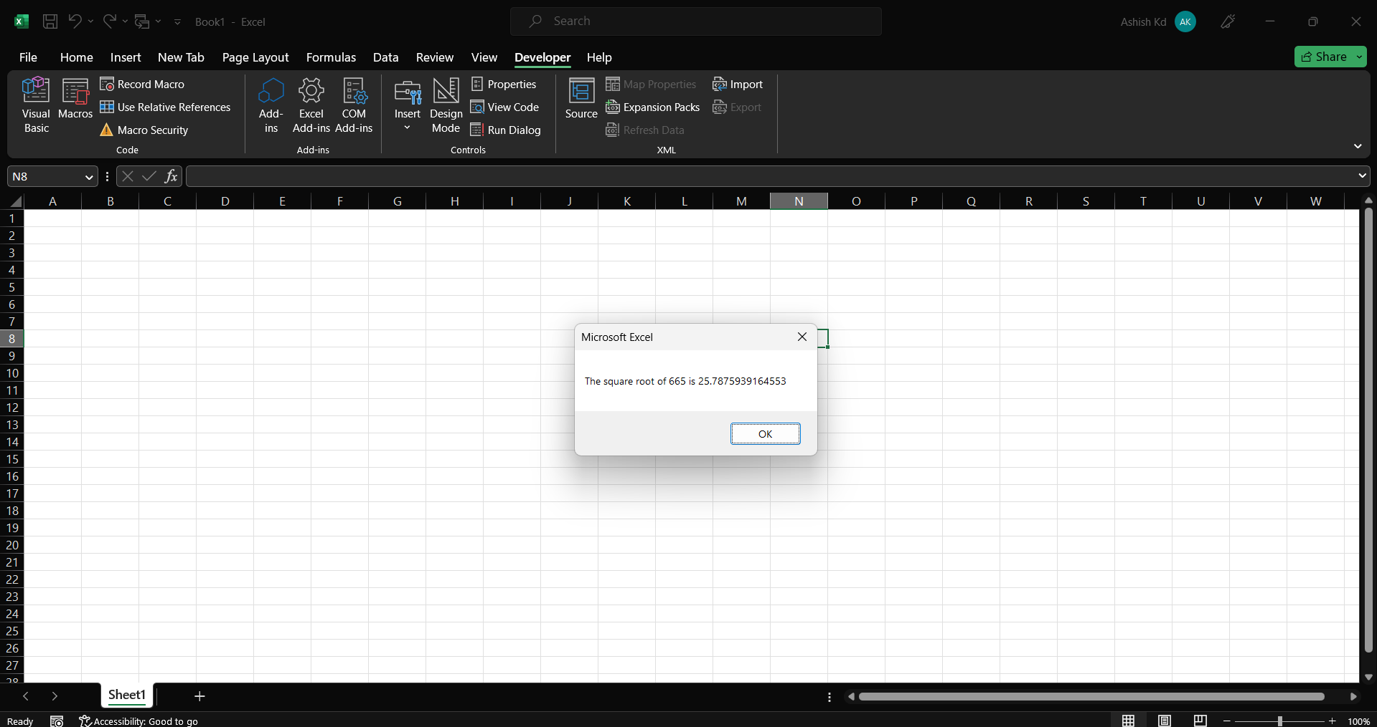

6. What are the shortcut keys used to

a. Run the code

b. Step into the code

c. Step out of code

d. Reset the code

Ans-

a. To run the code: press F5 or click on the "Run" button in the toolbar.

b. To step into the code: press F8 or click on the "Step Into" button in the toolbar.

c. To step out of the code: press Shift + F8 or click on the "Step Out" button in the toolbar.

d. To reset the code: press Ctrl + Break or click on the "Reset" button in the toolbar.